**Working With TDM**

Goto DataMaker and select **Project** from menu bar and select **Project Manager**. Right click on prject and create new project and version. Once version is created right click create datagroup, dataset and data pool subsequently. Click on Projects and select register from drop down. On the top right corner Select **Register table from Data Source** from drop down and run.

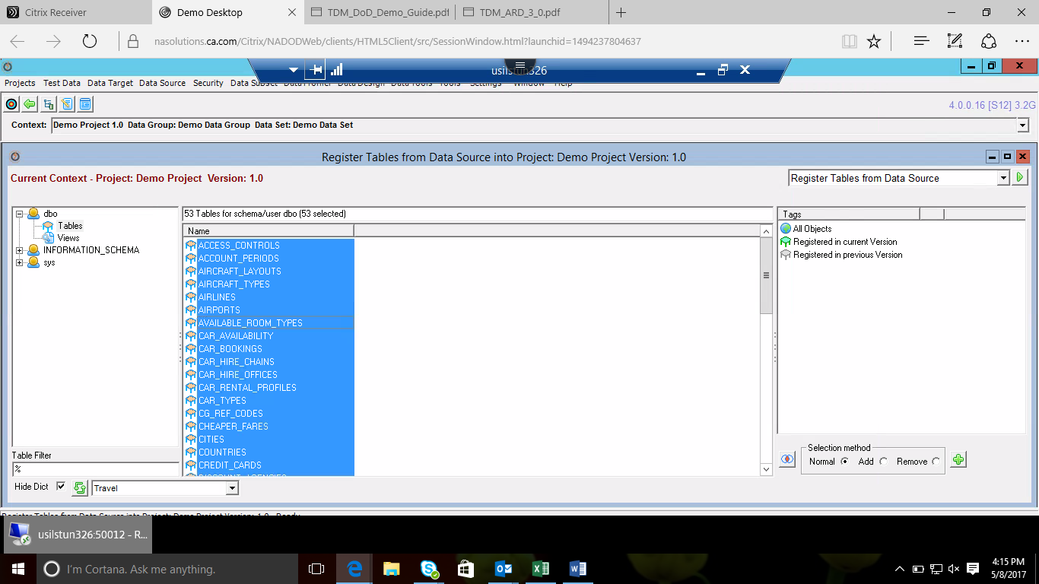

After running select all and again run

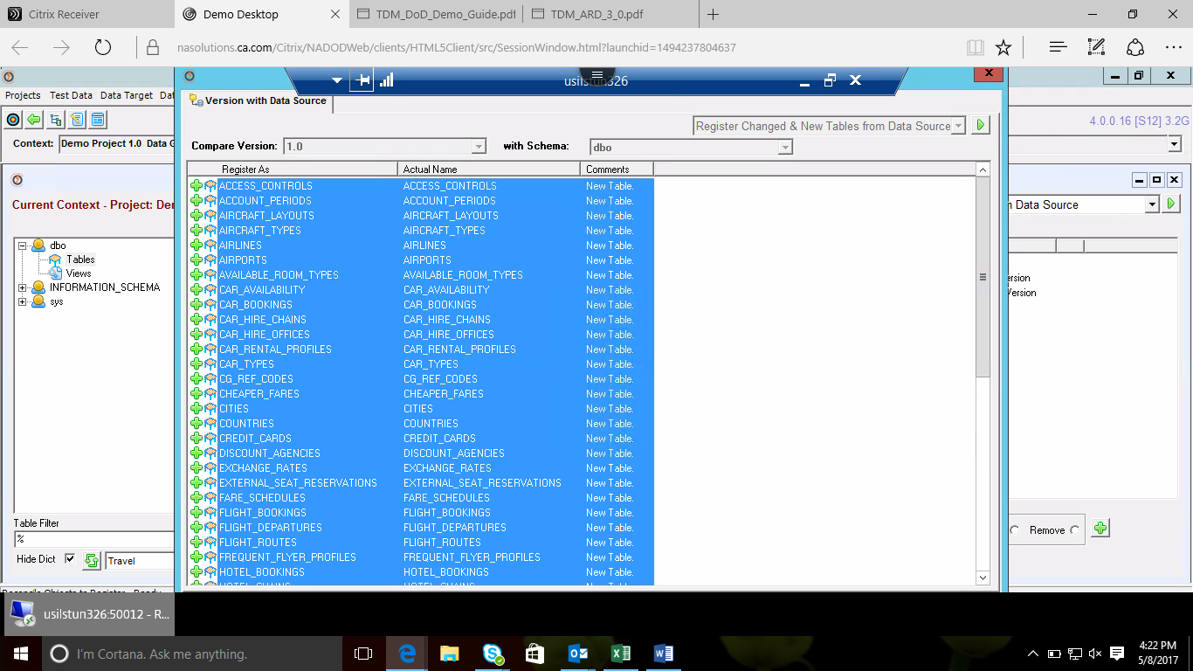

Tables are successfully registered.

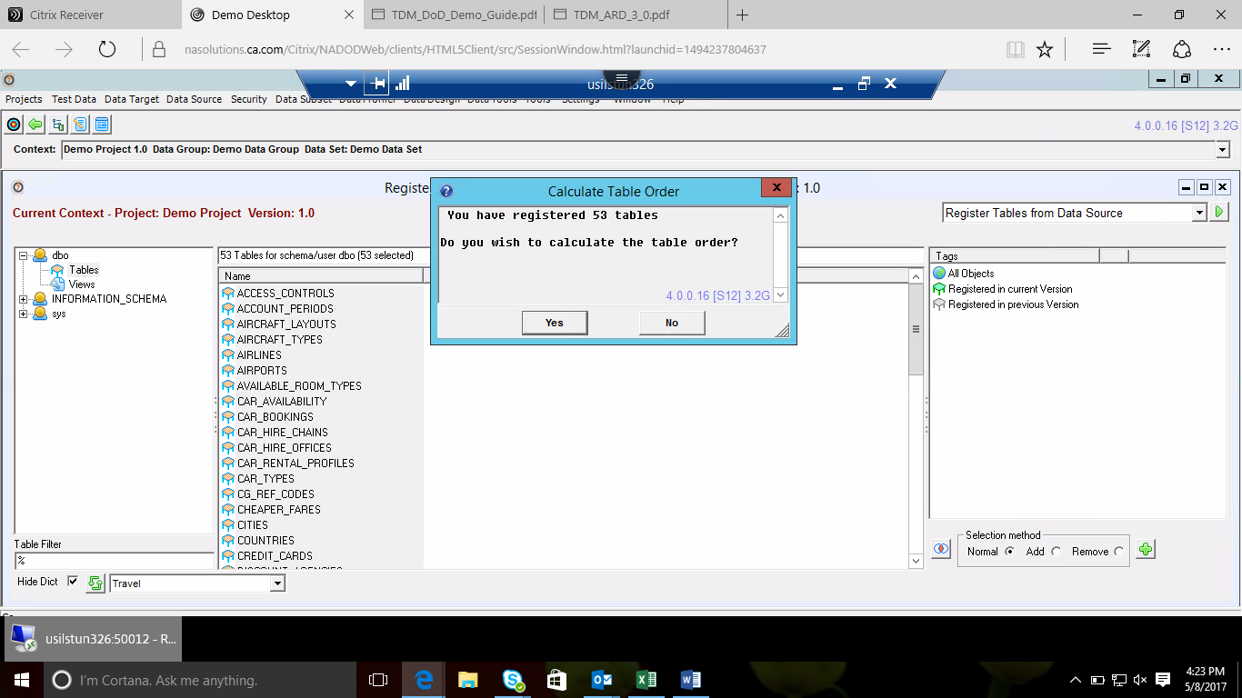

Select all the tables and select open tables from GTDiagrammer from top and run.

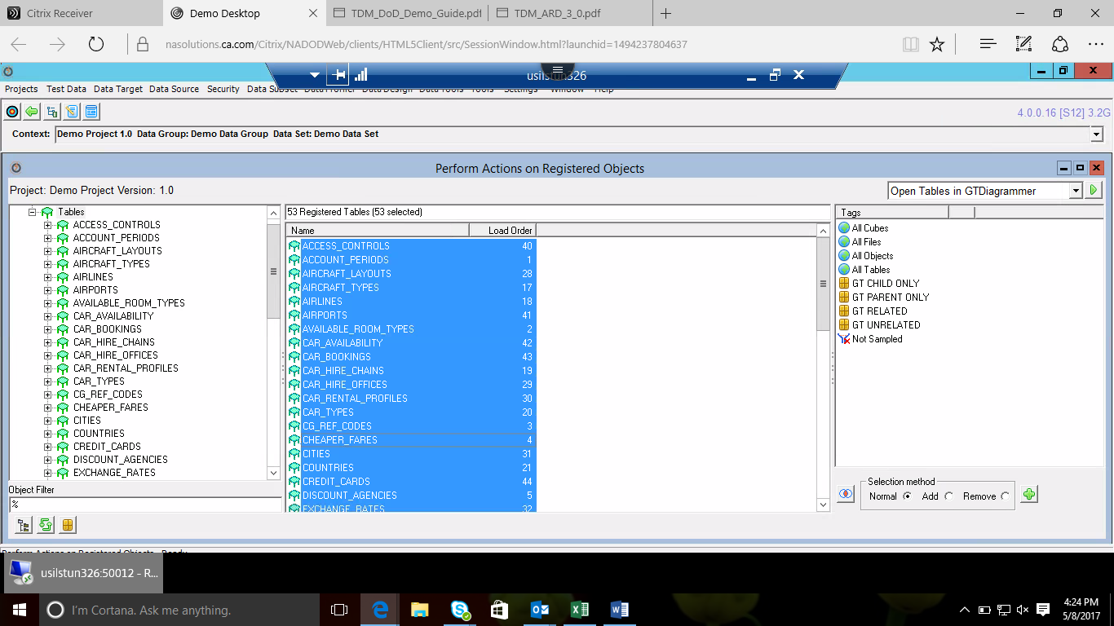

ER diagram

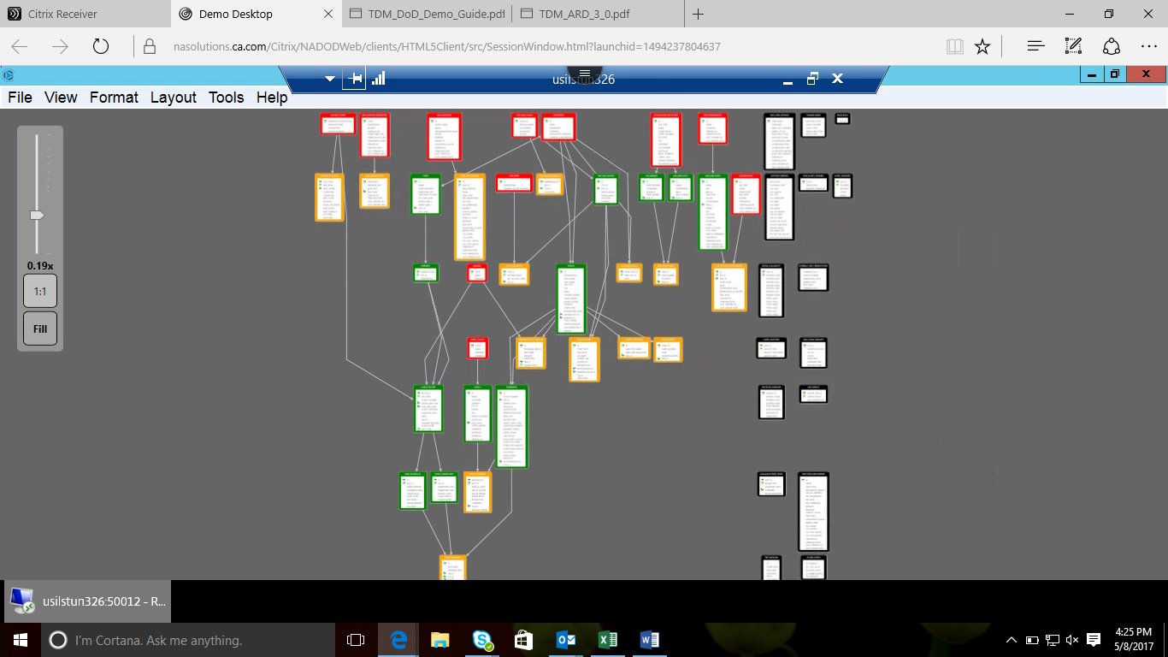

**Data Profiling**

Examining the content of data

Go to Data profile from title bar and then select Sample Table Data.

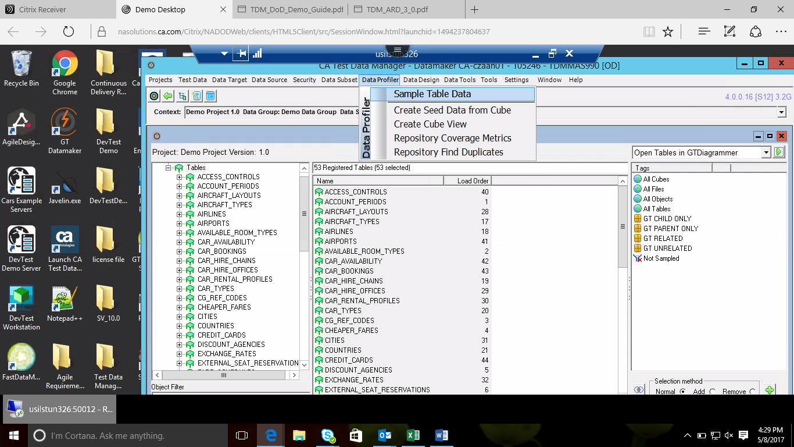

Select all tables and select **Sample Data** from drop down and run.

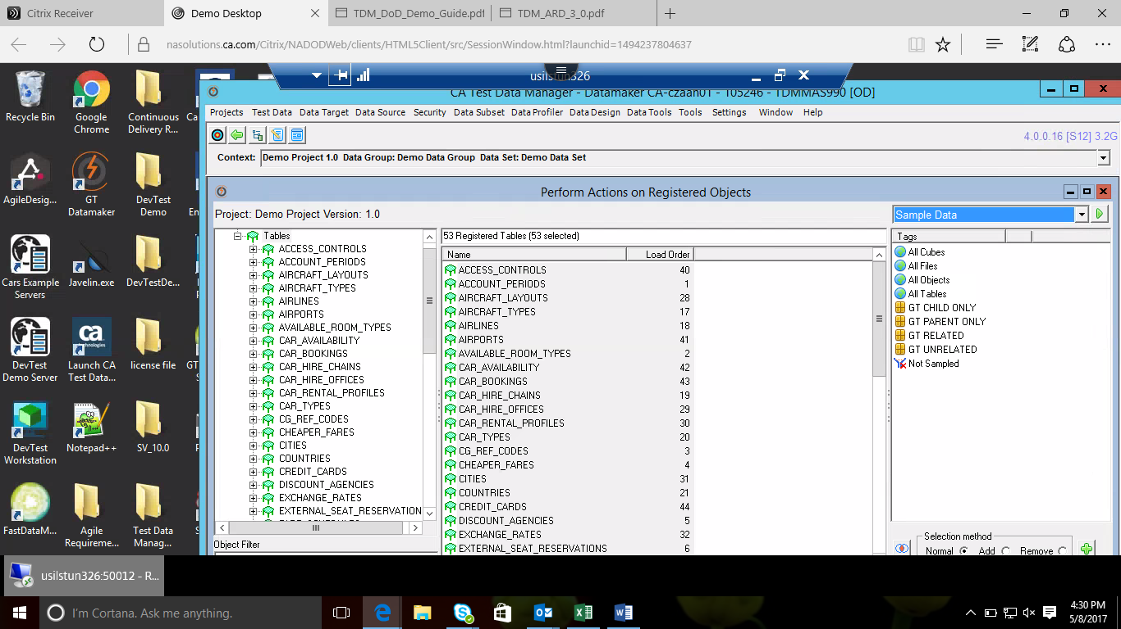

Click on build and save at the bottom.

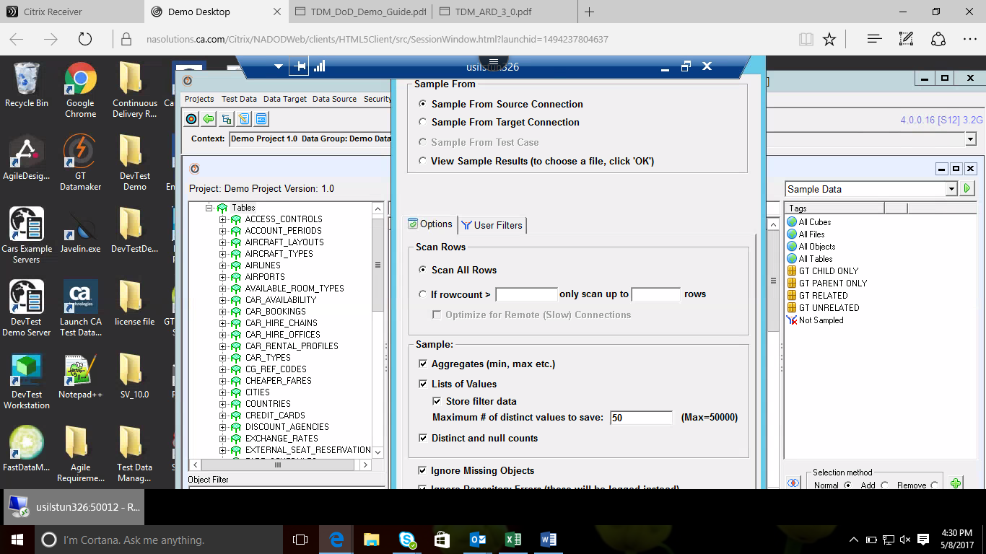

Check all the Colum names by clicking on **save** and run.

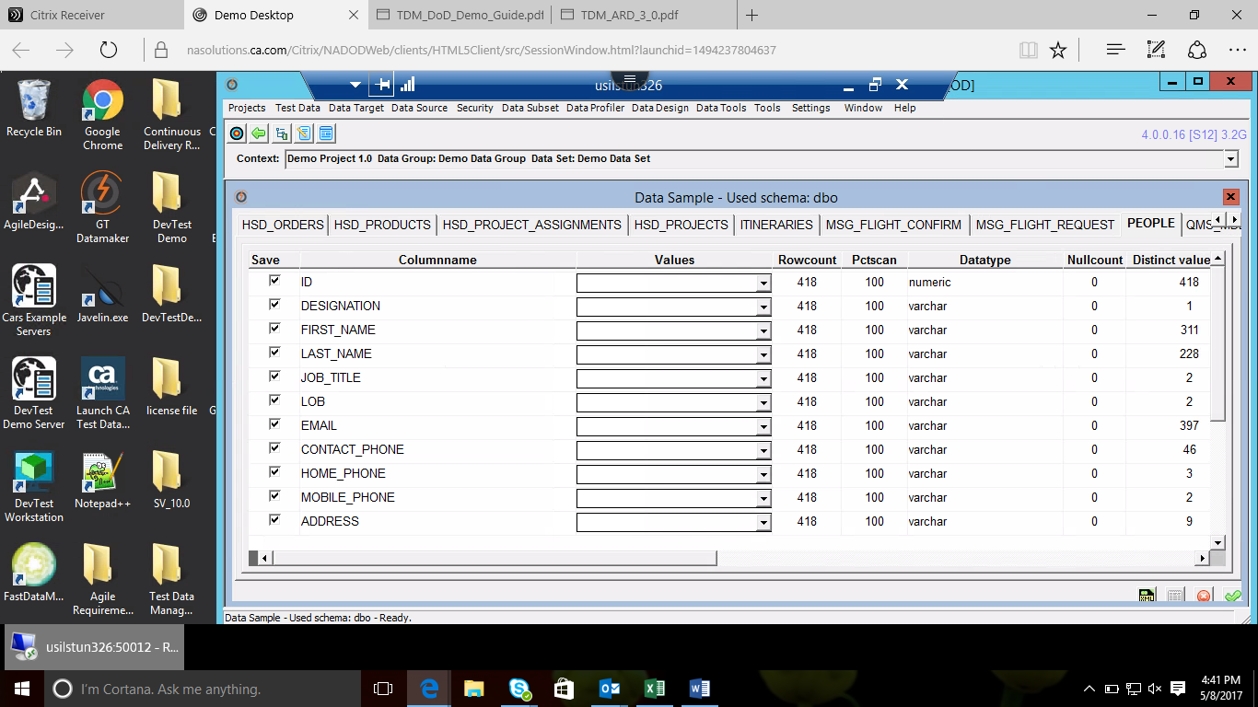

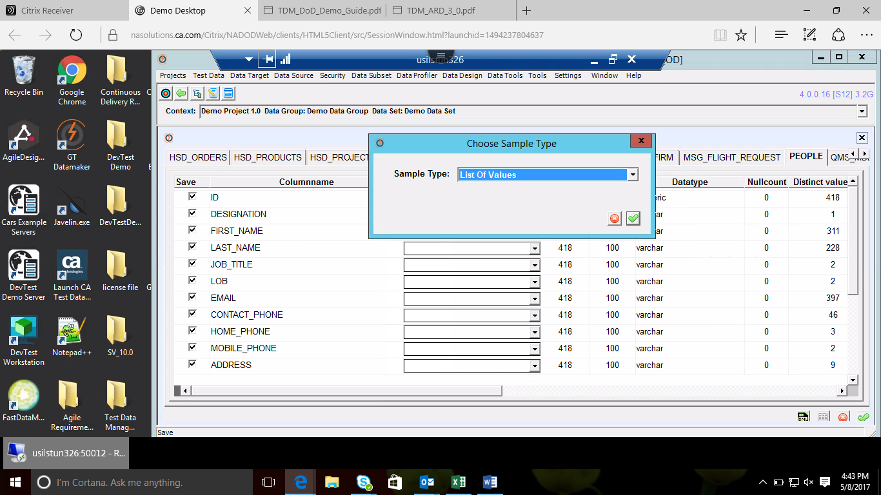

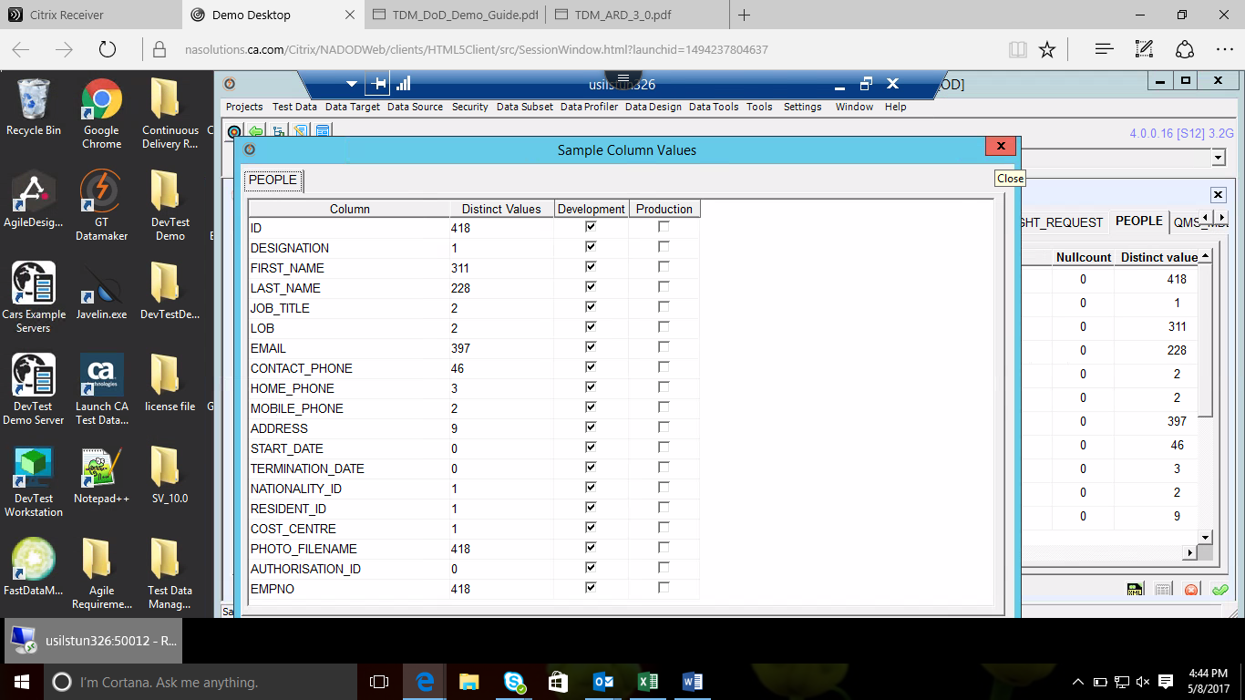

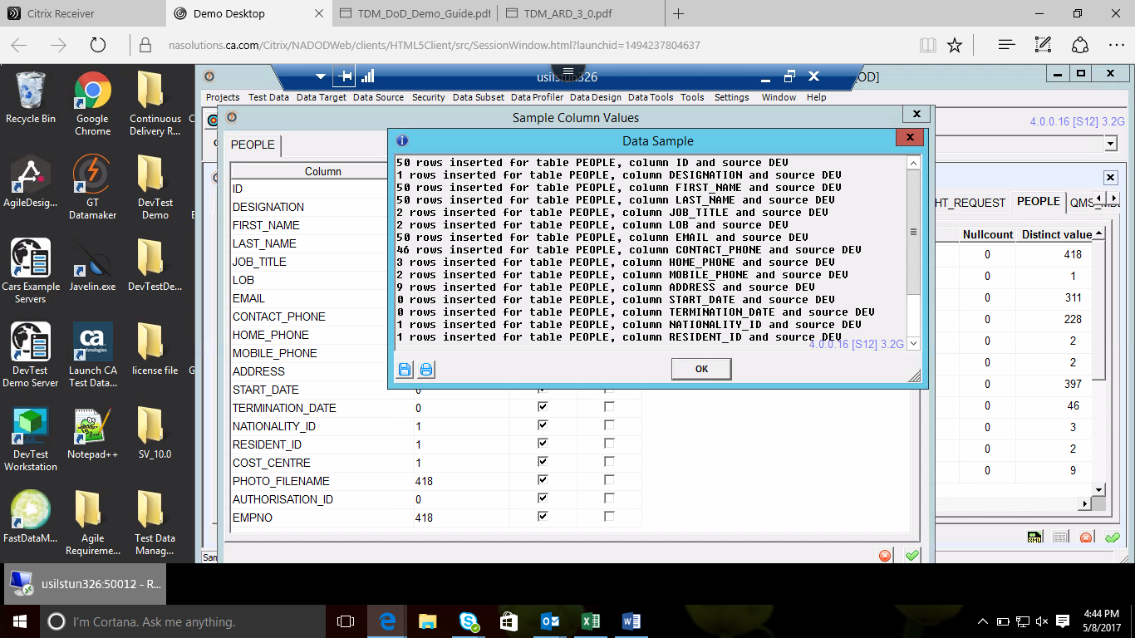

Click on generate reports

Generated Reports.

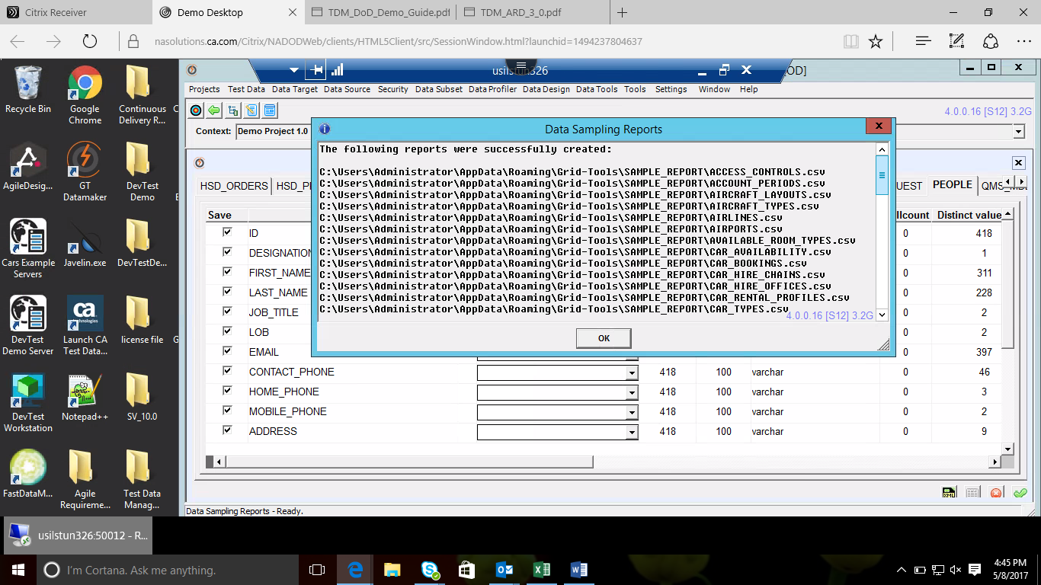

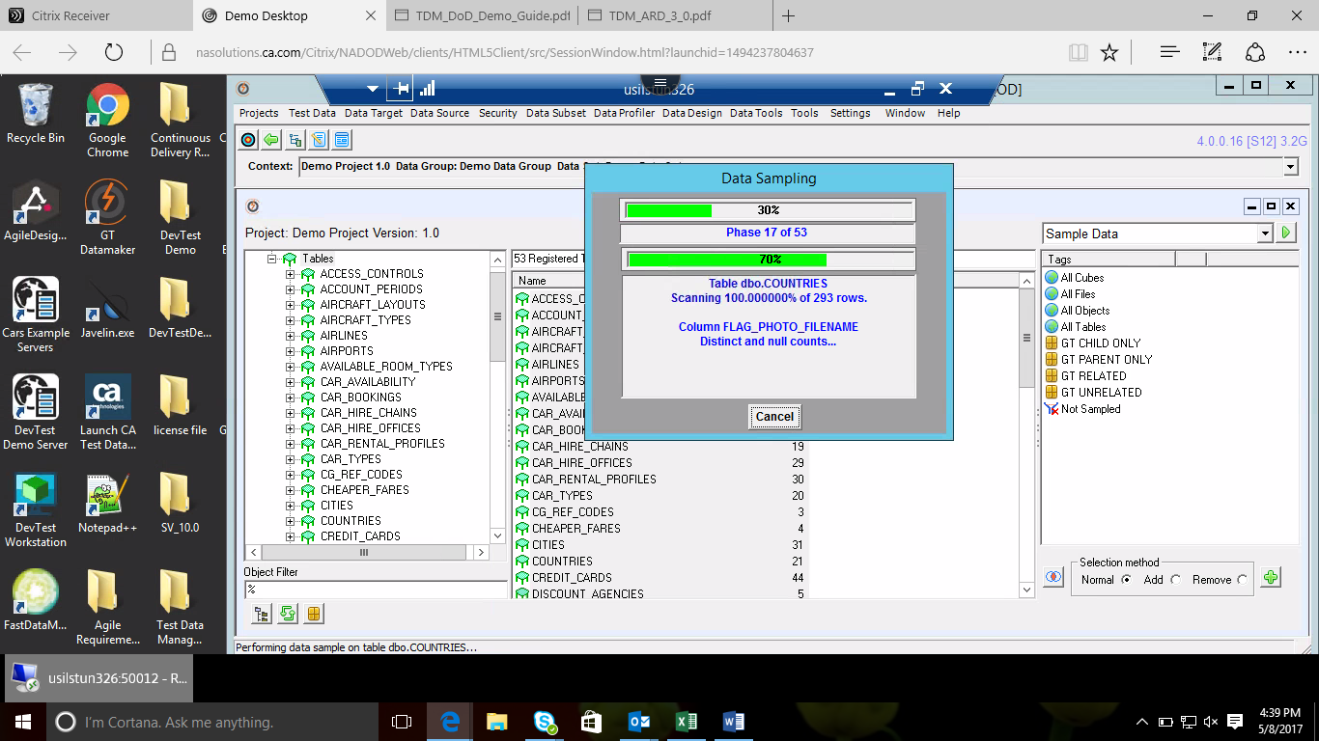

**Data**

Launch FastDataMasker from desktop. Select **connect_Travel.txt** from connections files. Uncheck encrypt and connect.

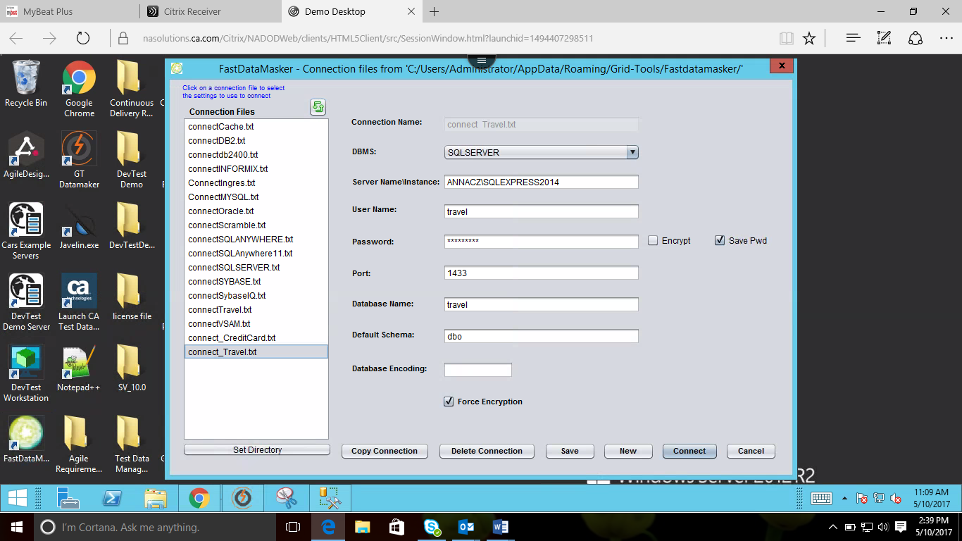

Select **People Table** from Available Tables and **add Column to mask** from dropdown(ex: Select email), mask type(fixed character).

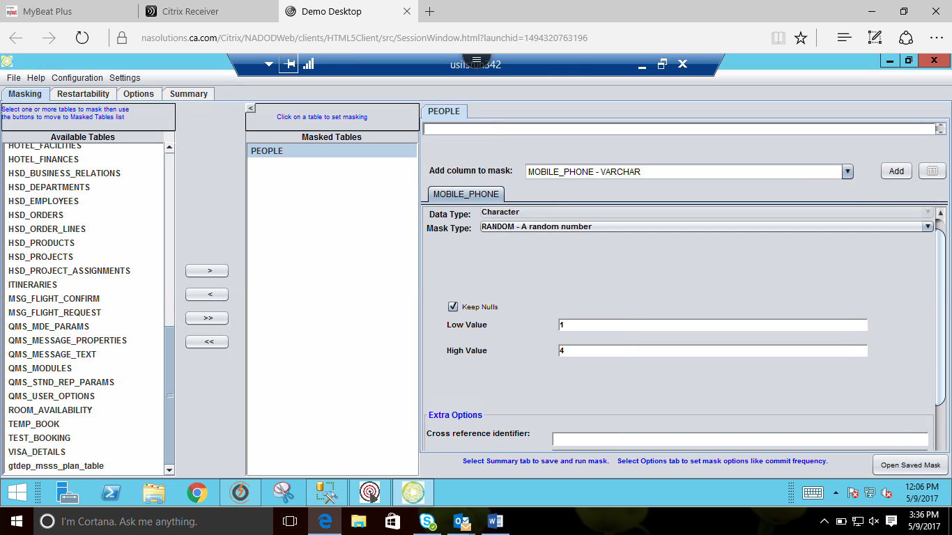

Goto **option tab** and add values in the respective rows.

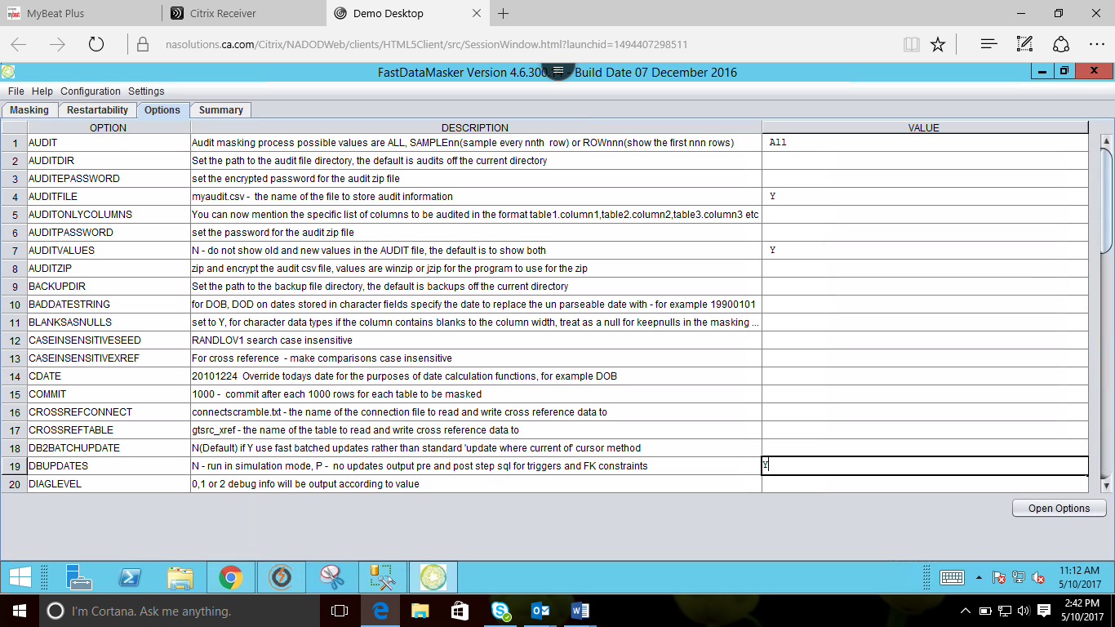

Goto **Summary tab** and click on **save and run mask.**

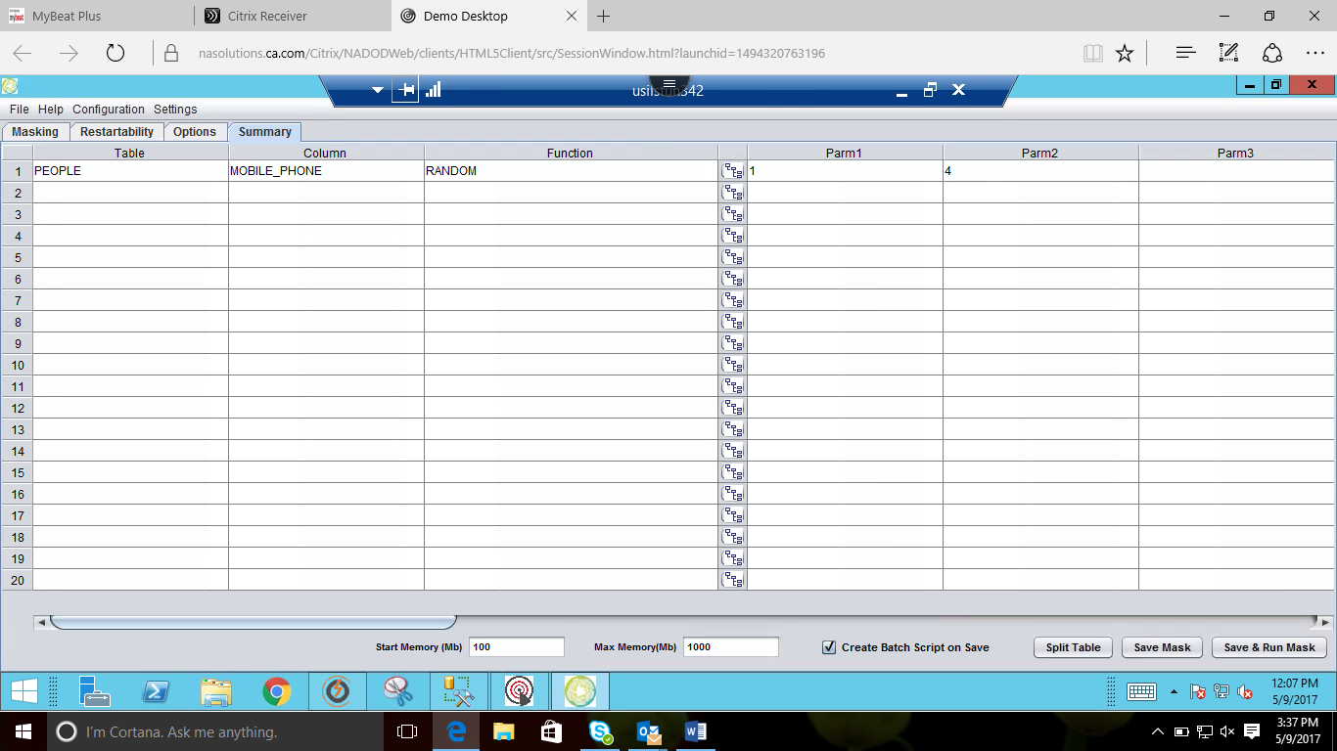

Specify the file name and save.

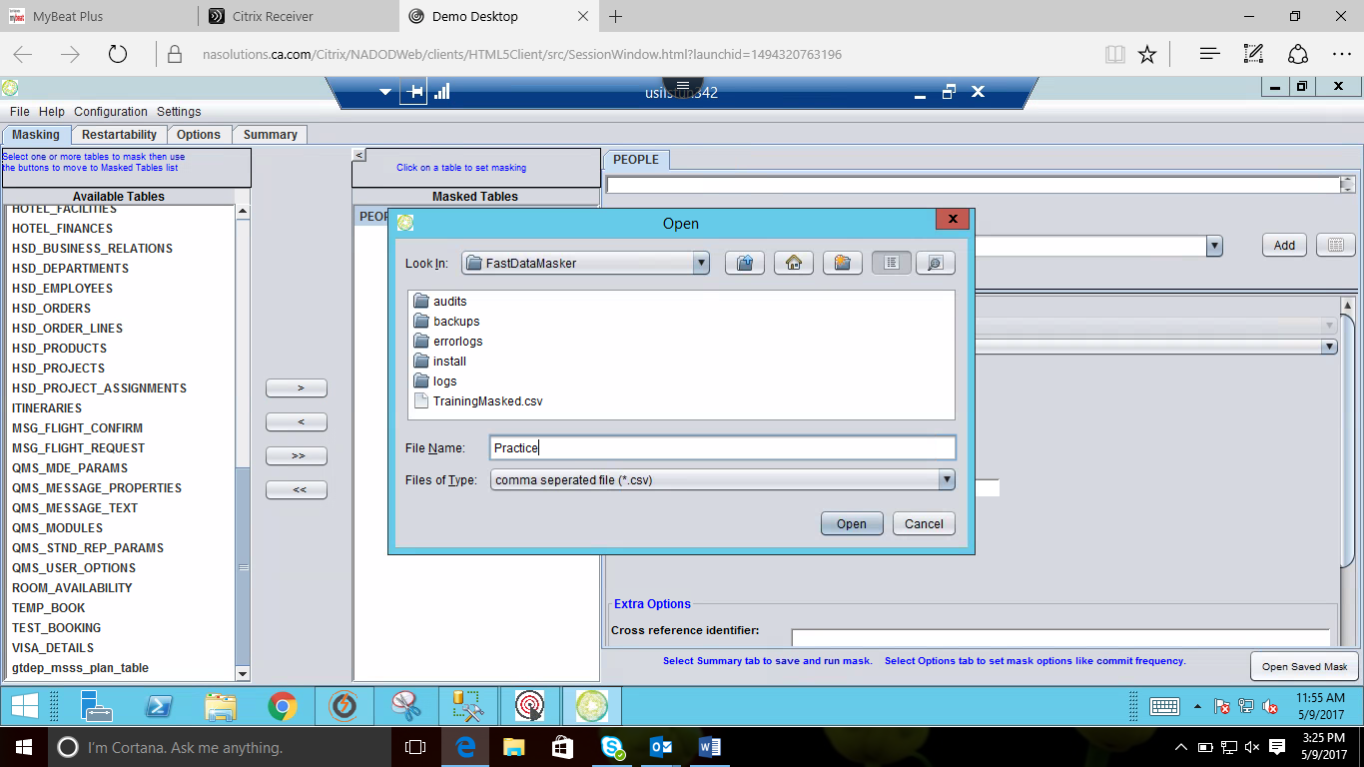

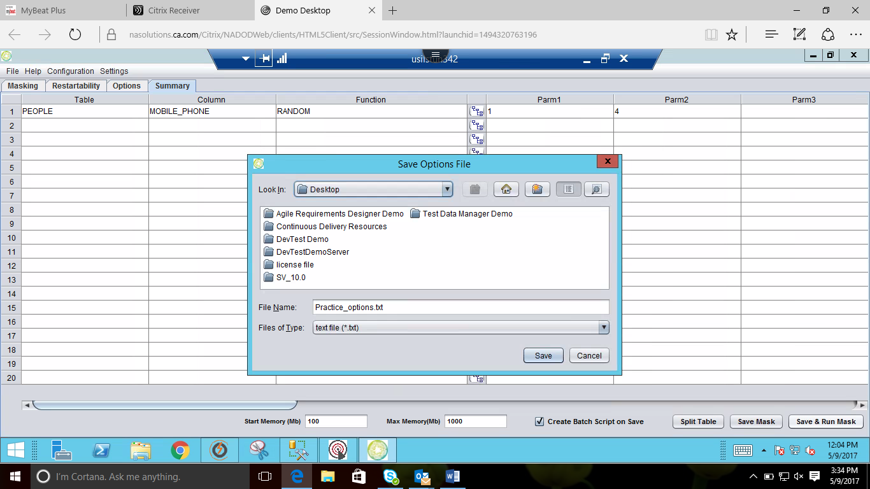

Shows the masked file location.

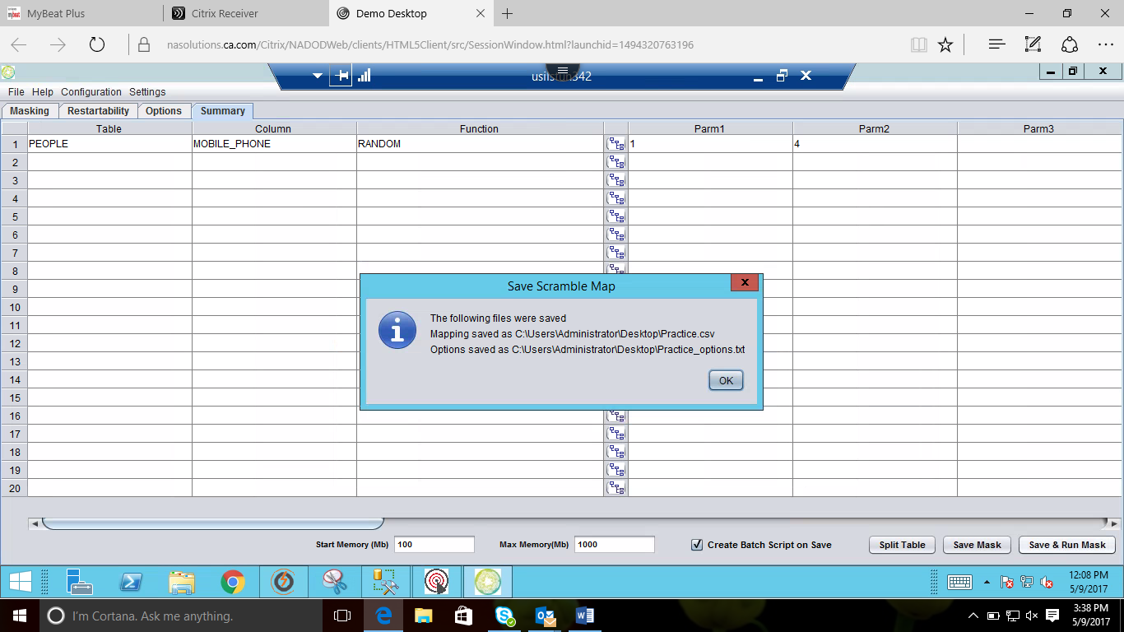

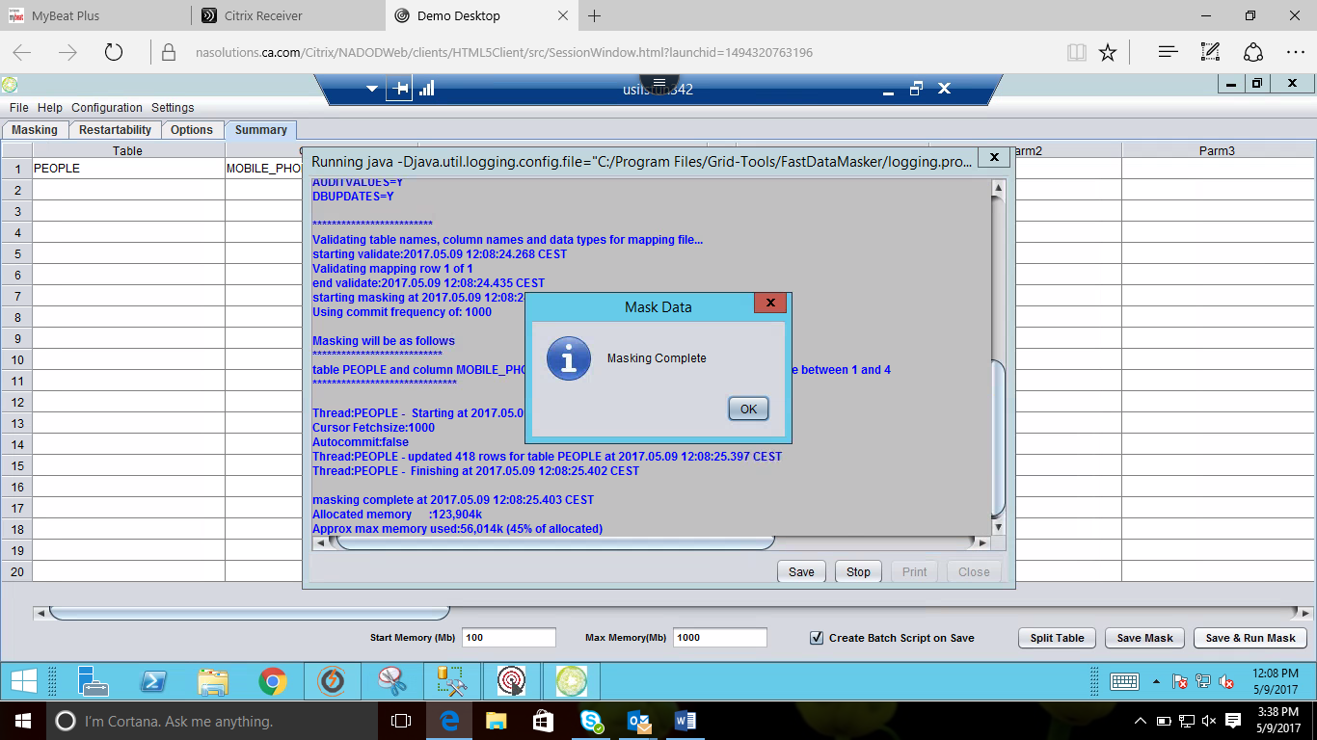

To view the masked file follow the path. **C://user/administrator/appdata/roaming/gridtools/fastdatamasker/audits/(choose the file that is masked)** or Just **click windows -> All program -> %AppData%**

**Synthetic Data Generation**

Goto Datamaker select the project, click on version and create new data pool.

After creating data pool goto projects click on **register** and select **Excel/CSV file.**

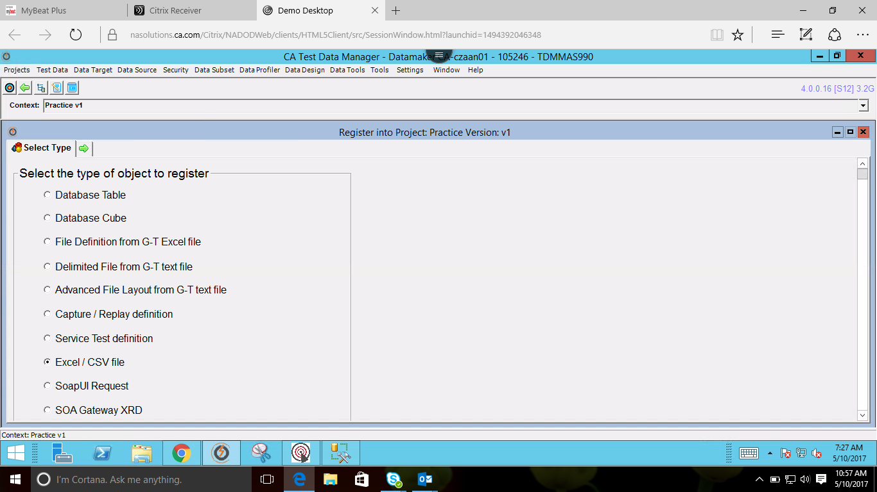

Browse the excel file from the file location, check all the **checkboxes** then click on **register and import.**

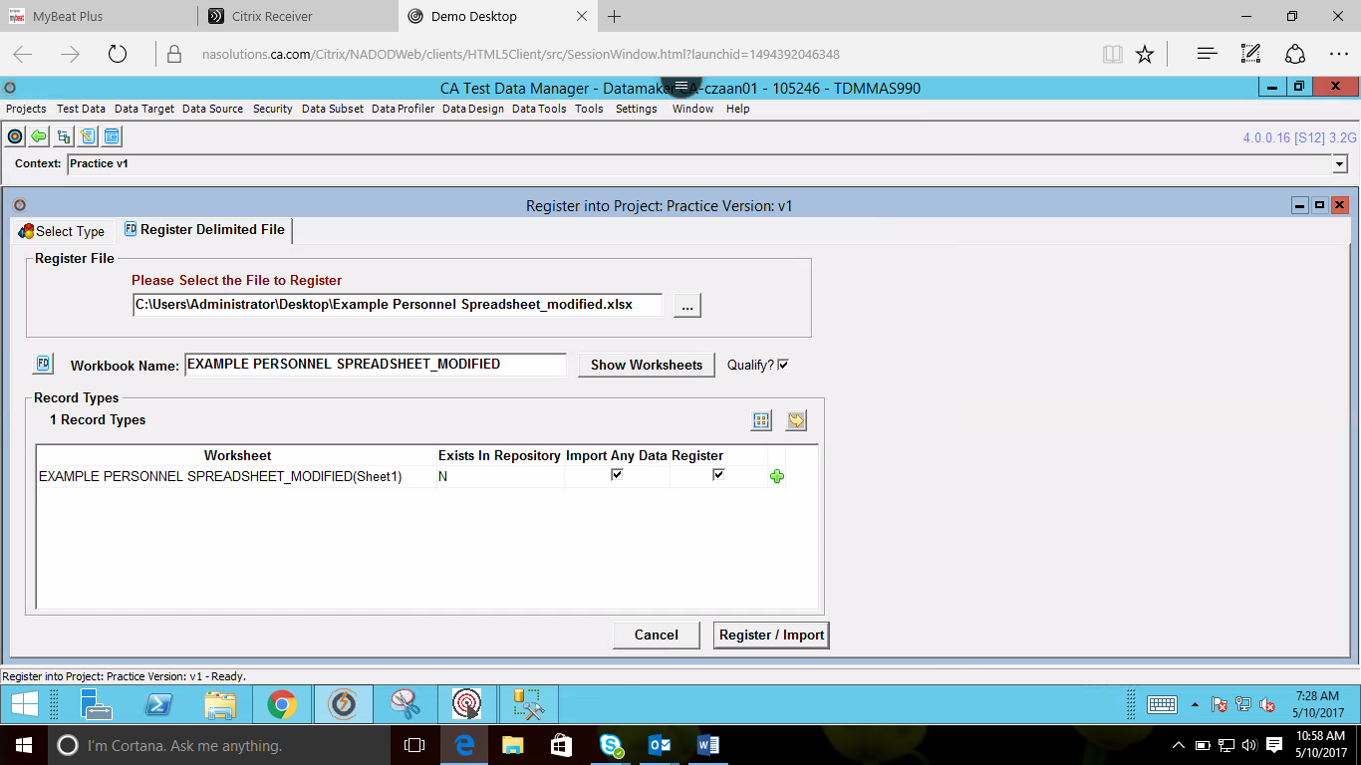

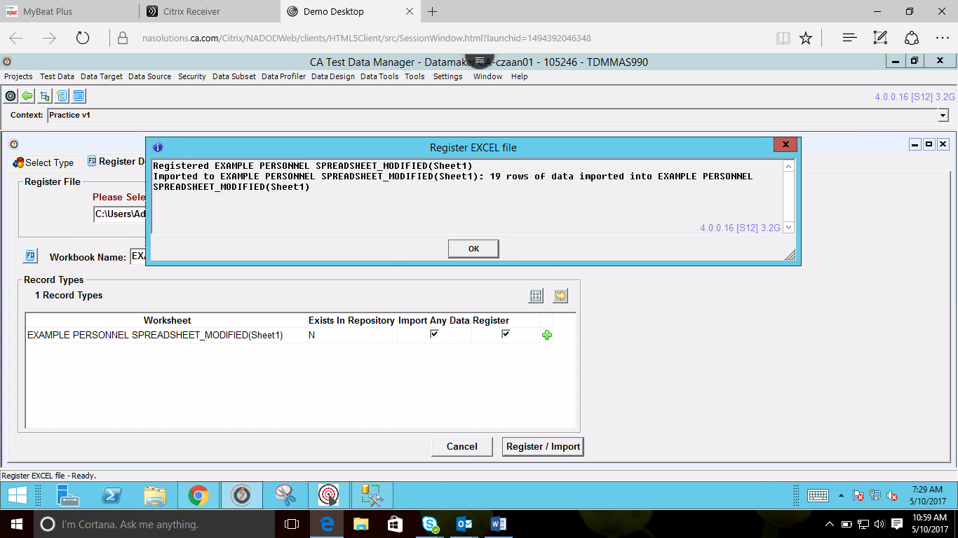

Goto project select **Action for Registered Objects** then click on goto datapool and double click on excel file.

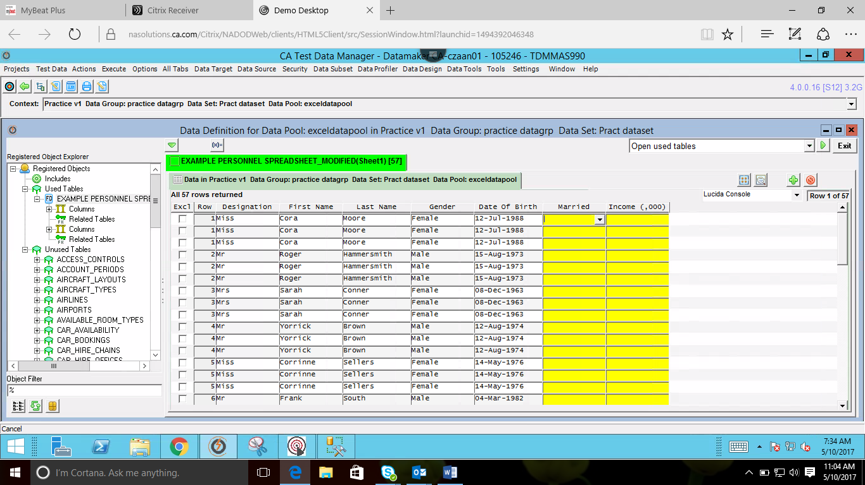

Double click on field select @randomseedname under listofvalues and then select required column need to be modified.

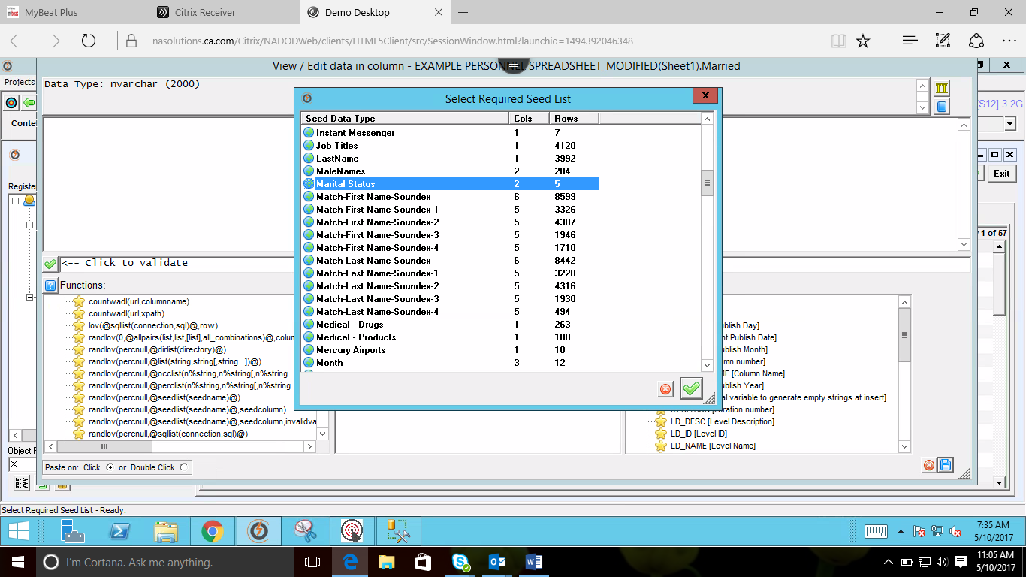

Percentile value should be set to 0.

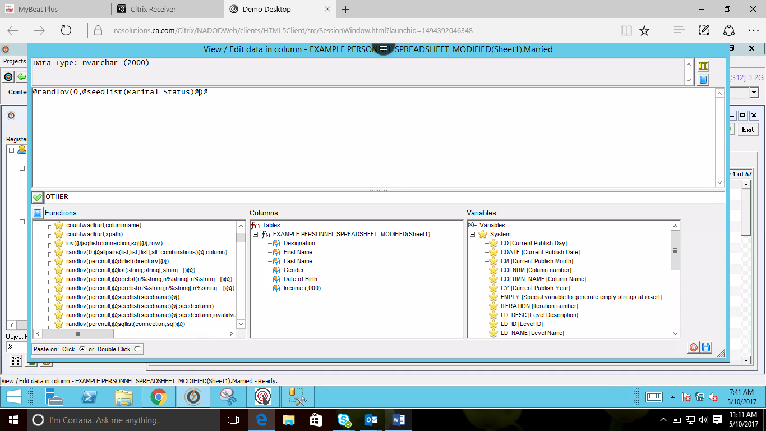

Similarly for Salary select Numeric function and randomrange(min,max).

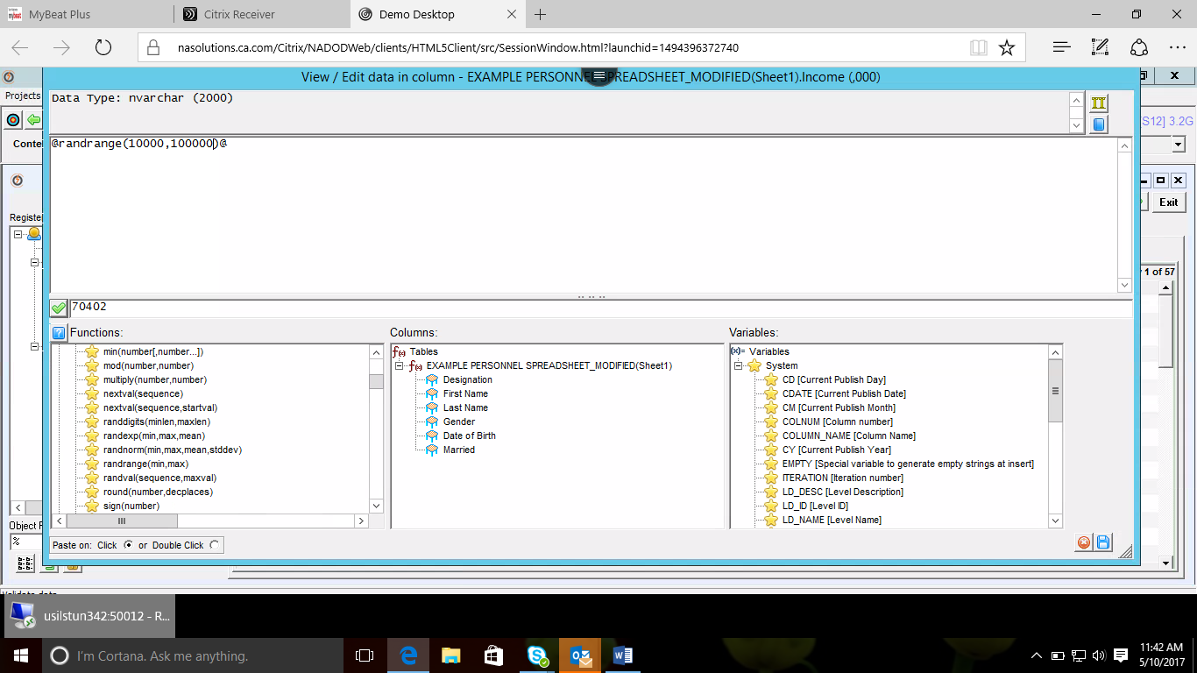

After validating the function click on preview icon from window

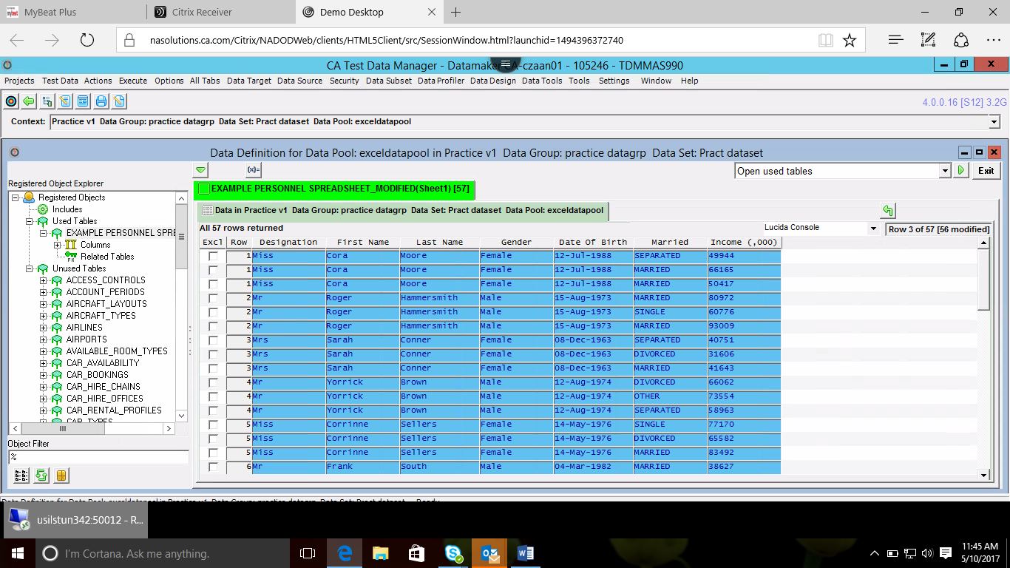

**Exporting data**

Select **publish to file** form the drop down.

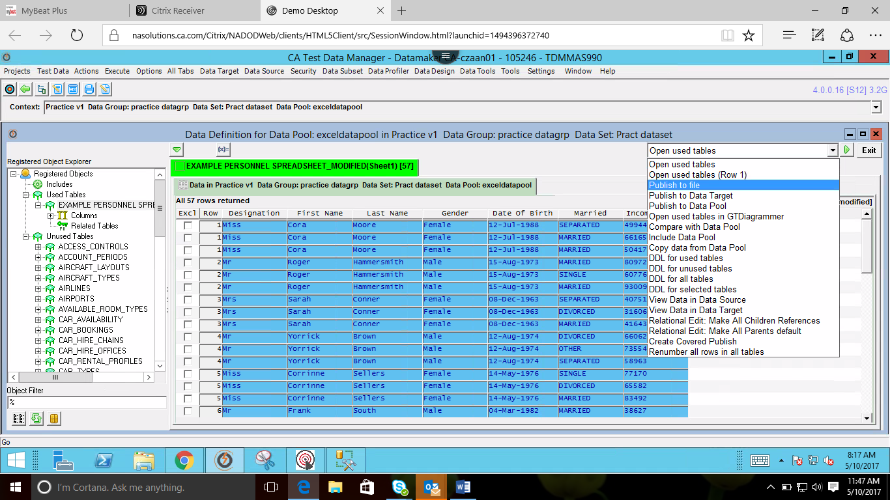

If required to generate more than 1 record enter the value in **Repeat** and **select publish to excel** from dropdown and run.

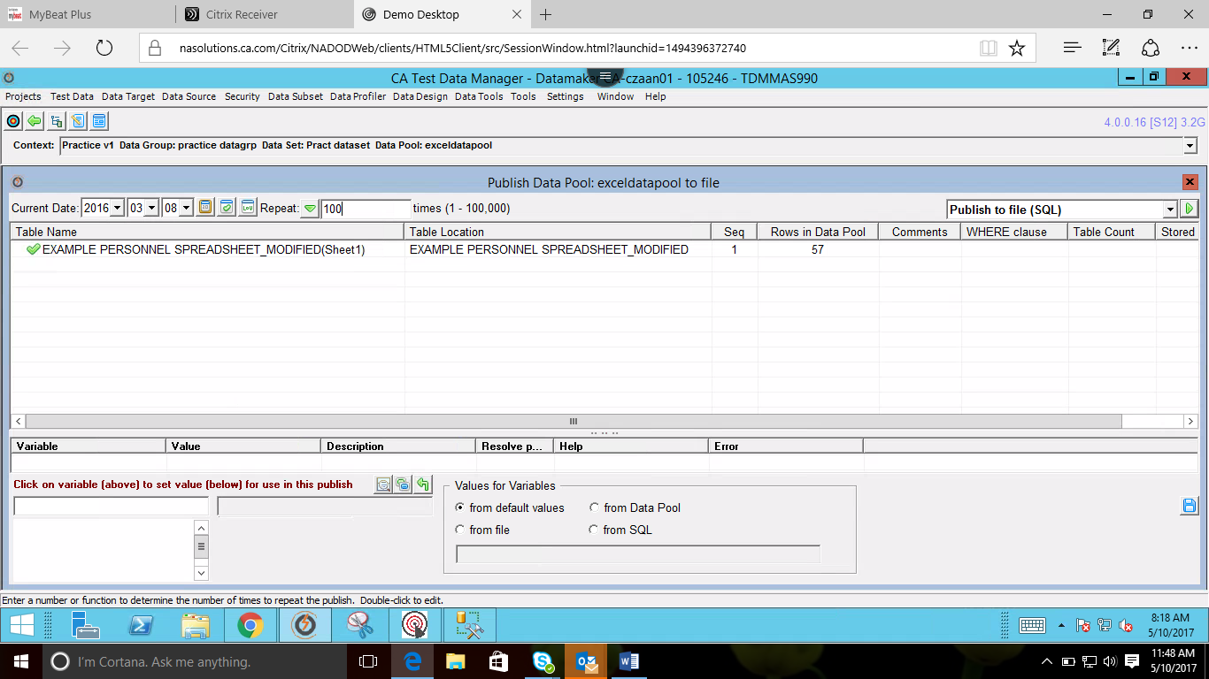

Select appropriately and run.

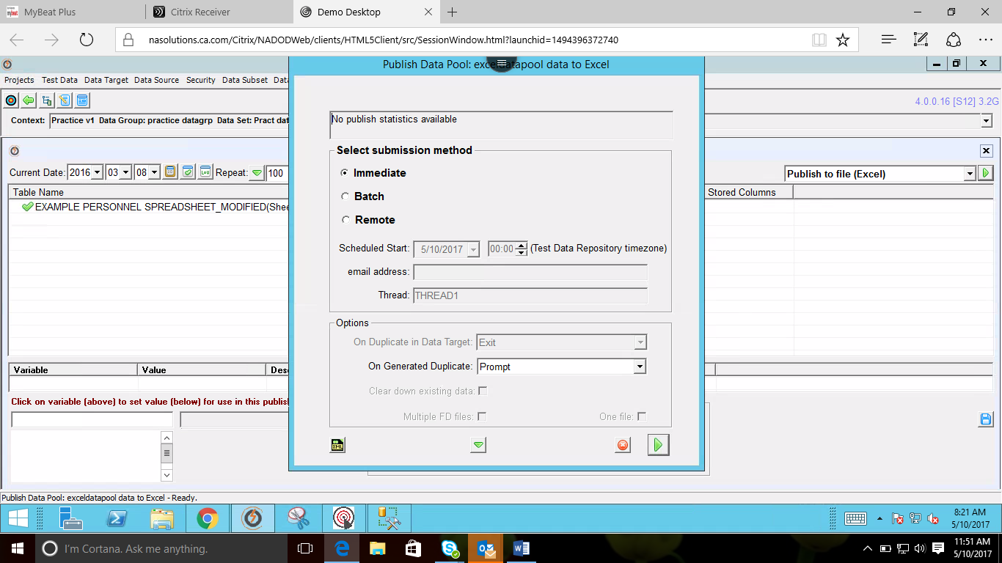

Choose the folder and run.

